The $z$ Distribution

The $z$ *distribution*, also called the *standard normal distribution*, is a normal distribution with a mean of zero and a standard deviation of one. It is used to standardize values in order to determine their probability. Probability in a $z$ distribution is represented as the area between the curve and the horizontal axis – often called the area under the curve. (This is actually true of all probability distributions – they all use area under the curve to measure probability).

Let’s draw a $z$ distribution and label some of its important features:

$z$ values are in units of standard deviations, so they express how many standard deviations away from the mean a particular value is. For example, a value that standardizes to a $z$ of $2.0$ is two standard deviations above the mean, while a value that standardizes to a $z$ of $-1.6$ is $1.6$ standard deviations below the mean.

The $z$*table* is used to look up probabilities for different values of $z$. The probability of a value falling at or above a given $z$ is called the upper tail probability, or *upper tail p-value.* The probability of a value falling at or below a given $z$ is called the lower tail probability, or *lower tail p-value*. The probability of a value falling a given distance away from the mean in either tail is called the *two-tailed p-value* (don’t worry – there will be more on this one later). These p-values will be very important in hypothesis testing, where they will be the evidence in the *p-value approach to rejecting the null hypothesis.*

*Example 1*. What is the probability that a randomly drawn z value would be greater than or equal to 1.24? This is what is called the **upper tail p-value** of $z=1.24$

*Example 2.* What is the probability that a randomly drawn z value would be less than or equal to $-1.84$? This is what is called the **lower tail p-value** of $z=-1.84.$

*Example 3.* What is the probability that a randomly drawn z value would be at least $2.15$ standard deviations away from the mean? This is what is called a **two-tailed p-value**.

Now it is your turn! Try the three exercises below.

*Exercise 1.* What is the UT p-value of $z=2.50$?

*Exercise 2.* What is the LT p-value of $z=-1.00$?

*Exercise 3.* What is the 2T p-value of $z=-2.82$?

**Critical Values of Z**

Critical Values (CVs) are values of $z$ with given tail probabilities. In notation, Critical Values are always subscripted with a probability. In general, $z_{α}$ is the CV of $z$ with $α$ probability in the upper tail, and $-z_{α}$ is the CV of $z$ with $α$ probability in the lower tail.

Some common CVs of $z$ are given in the inset table on the first page of the z table, reproduced here:

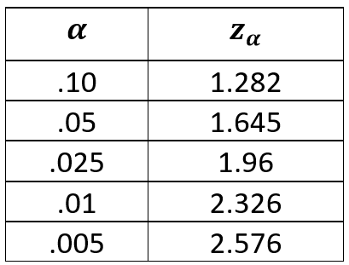

where $α=$ the tail probability

and $z_{α}=$ the Critical Value of $z$ with $α$ probability in the tail

*Example 4.* Look up the **upper tail CV** of $z$ at $α=0.05.$ Draw and fully label the $z$ distribution showing the CV and shading in the tail probability.

*Example 5.* Look up the **lower tail CV** of $z$ at $α=0.01.$ Draw and fully label the $z$ distribution showing the CV and shading in the tail probability.

*Example 6.* Look up the **two-tailed Critical Values** of $z$ at $α=0.05.$ Draw and fully label the $z$ distribution. Here are the steps to look up the 2T CVs:

1. Split $α$ between the two tails by dividing $α$ by 2
2. Look up the LT CV of $z$ at $α/2$ and the UT CV of $z$ at $α/2$. These are your 2T CVs.

**Why do we need Critical Values?**

Critical Values can give us information about the p-value (the probability) of other values of $z$. This use of CVs will be very important in hypothesis testing, where they will be the evidence in the *Critical Value approach to rejecting the null hypothesis.*

What is the UT CV of $z$ at $α=0.10?$ Draw and fully label the $z$ distribution. What can this picture tell us about the UT p-value of $z=4.1?$